6.Demonstrate how a JDBC sampler script is run in JMeter.

* Download the JDBC connector jar file
* Open the browser of the lab and open this URL
* https://dev.mysql.com/downloads/connector/j/
* In the drop down select platform independent
* Select the second option : Platform Independent (Architecture Independent), ZIP
* Click on download button
* on next page click on => No thanks, just start my download.
* Zip file will be downloaded.
* Now go to downloads folder of lab
* and right click on zip file and clickon extract here
* In the folder there will be a JDBC connector.jar file

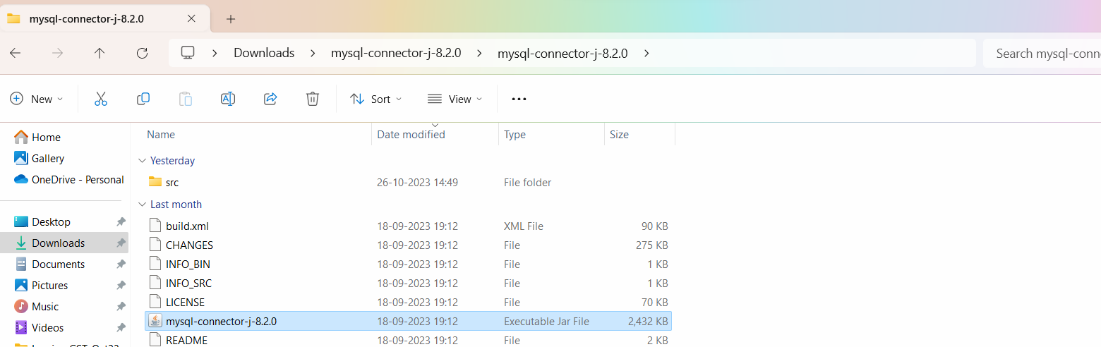

This Jar file has to be copied and pasted in your Jmeter folder 🡪lib folder

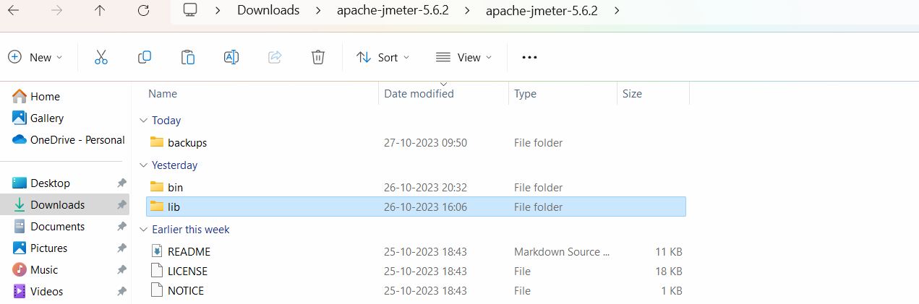

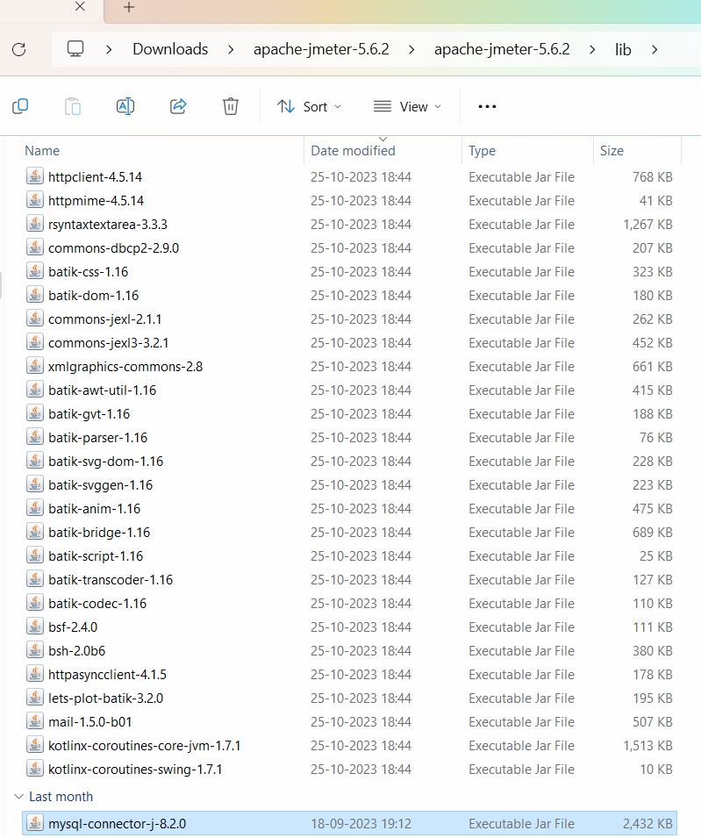

After copying the jar file in LIB folder🡪 restart your apache Jmeter (close it and start it again).

In JMeter🡪 create a Thread group -🡪 Add 🡪 Config Element🡪 JDBC connection Configuration

Add the variable pool name and add DB connection details.

